Object-oriented Analysis and Design

Kendra M.L. Cooper
The University of Texas at Dallas
Mail Station ECS 3.1 2601 North Floyd Road
Richardson Texas, USA 75083
kcooper@utdallas.edu

Introduction
Methodologies to support the systematic design of software systems have been evolving for over 35 years. Building on the concepts of structured programming, DeMarco, Yourdon, and Constantine proposed structured analysis and structured design (SASD) in the early 1970’s. SASD provides processes and notations, which are used to produce hierarchical, functional decompositions of the system. With this strategy, each subsystem is decomposed and provides more detailed explanations of the functional capabilities it provides. The SASD designs could be readily implemented in third generation programming languages such as Fortran or C. SASD evolved and grew in popularity to dominate the field until the 1990’s. In its evolution numerous variations have been proposed; comprehensive surveys of structured design techniques are available [32][42].
The emergence of object-oriented programming languages [10], however, drove the need for new design methodologies. The new, object-oriented programming languages focused on a decomposition strategy that encapsulated data (i.e., state) and behavior into integrated entities called objects. This lead to fundamental mismatches between an SASD design (functional decomposition with data and behavior separated) and its object-oriented implementation (object-oriented decomposition with data and behavior integrated). To resolve this, object-oriented design methodologies were proposed. Many ideas about object-oriented design came out with the work of Abbott [1], followed by Booch [8]. Abbott and Booch recommended that a design should start with an informal description of the real-world application; using this description, designers could identify classes and objects from nouns and operations from verbs. Booch’s work was significant because it was one of the earliest object-oriented design methodologies to be described. Following this early work, numerous alternative approaches were proposed. Surveys in [10][42] consider over 20 approaches, the majority proposed in the early 1990’s. Each proposed a set of modeling heuristics and their own notation to capture the analysis and design models. The proliferation of methodologies and notations lead the community to an effort to consolidate the approaches. This effort resulted in the definition of the Rational Unified Process (RUP) [23] and the Unified Modeling Language (UML) [31].
Today, the broad phrase “object-oriented design” consists of three design activities: software architecture; object-oriented analysis; and object-oriented design. These activities are performed iteratively and can sometimes overlap. For example, a candidate software architecture is initially proposed, which defines the overall structure and behavior of the system. The architecture is refined as the analysis and detailed design activities proceed. The goal of the analysis activity is to identify a preliminary mapping of required behavior onto modeling elements in the system. The goal of the detailed design activity is to transform (refine and restructure) this preliminary mapping into a set of model elements that can be implemented.
Object-oriented design has been evolving as a discipline for over 25 years and is now a set of established activities in software engineering. The activities transform the requirements into multiple levels of design (architecture, analysis, detailed). The detailed design is then realized in code (Figure 1). The topic is covered in general software engineering books [9][33][34][38] and surveys on object-oriented methodologies are available [10][19][42]. A widely-used object-oriented approach to analyze and design a system is defined in the Unified Process (UP) [5][21][23]. UP is a comprehensive software engineering approach, which is based on a set of software development principles and best practices.
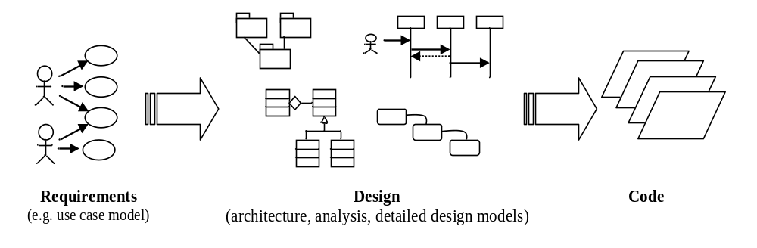
Figure 1 Object-oriented Software Development

The Unified Modeling Language (UML) 2.0 is a well-known notation for specifying, visualizing, constructing, and documenting designs of software systems. It provides graphical notations to express the design of software systems with semi-formal syntax and semantics, and an associated language, the Object Constraint Language (OCL), for expressing logic constraints. UML contains thirteen diagrams, which can be classified into two basic diagram types: structure diagrams and behavior diagrams. Structure diagrams depict the static structure of the elements in the system, including class, composite structure, component, deployment, object, and package diagrams. Behavior diagrams depict the dynamic behavior of the elements in the system, including activity, statechart, use case, communication, interaction overview, sequence, and timing diagrams. A subset of diagrams is typically used in OOAD, including class, sequence, and state transition diagrams.
This article begins with an overview of the object-oriented paradigm that includes descriptions of key principles and basic concepts in addition to an established object-oriented modeling notation (Unified Modeling Language) in Section 2. Following this, presentations on the object-oriented analysis and object-oriented design activities are provided in Sections 3 and 4. The presentations include an introduction, description of the activity’s workflow, and approaches used to evaluate the quality of the models produced. Conclusions are in Section 5.

Object-oriented paradigm

Object-oriented Principles
There are three main principles in the object-oriented paradigm: abstraction, encapsulation, and inheritance. The principle of abstraction allows developers (engineers, computer scientists) to represent a solution to a problem that more closely resembles the real world problem domain. For example, when developing an on-line banking system, entities such as a bank account, loan agreement, or customer data (name, address, employer, etc.) can be represented directly in the analysis and design models as interacting classes and objects. The close relationship between the entities in the real world and the entities in the models makes it simpler to develop, analyze, verify, and maintain the models. These models can be readily implemented in an object-oriented programming language, which also support the object-oriented concepts.
The principle of encapsulation provides a way to organize a class as an independent unit, i.e., one that can encompass all the operations and data attributes for a portion of the real world. The class publishes its externally visible operations interfaces, while hiding the internal details. In other words, how the class realizes an interface is the responsibility of the class. Consequently, each class is considered as a blackbox, which interacts with other classes to provide functionality. With this approach, the internal details of a class can be modified without changing the way classes are used. For example, the implementation of an operation that searches through customer data could be replaced with a more efficient solution without changing how the operation is used by another class. Encapsulation improves the modularity of classes, which supports the re-use of classes across different applications, simplifies the development of the models, as details are abstracted away, and reduces the maintenance effort.
The principle of inheritance provides a re-use approach, which allows classes to share attributes and operations. Classes can be organized into a hierarchical relationship. A class higher up in the hierarchy, called a superclass or parent class, can be re-used to derive new classes, which are called subclasses, derived classes, or child classes. A new child class can retain the data and operations of its parent in addition to having its own specialized data and operations. The parent class remains unchanged. For example, a banking account class may be specialized into a savings account, checking account, money market account, etc. The common data or operations can be developed in the parent class and re-used in the children classes, rather than redeveloping the capabilities in many places.

Object-oriented Concepts
Basic concepts used in the object-oriented paradigm include classes, instances of classes called objects, and relationships. Within classes there are operations and attributes; these have specific visibility. An overview of these concepts is provided in this section along with their representation in the UML.

Classes
A class encapsulates a set of data attributes and a set of services, or operations. It is used to represent “things” in the real world problem domain. Attributes store data; when fully defined each attribute has a name, type, brief description, constraints, and visibility. For example, attributes for a bank account class can include: account number; customer identifier; balance; overdrawn. The account number can be defined as a unique, nine digit, positive integer with visibility of private (only the objects of this class can access the data). Operations access and/or change the values of the data attributes; they have a name, brief description, defined parameters and return type, constraints, and visibility. For example, a bank account operation to calculate the interest for an account can be defined to not require any parameters, return a currency value in U.S. dollars, and have a visibility of protected (only objects within this class inheritance hierarchy can access the operation).
Sample classes are illustrated in Figure 2 for a banking example. The example uses the UML class diagram as the notation. The classes in a UML class diagram are represented by rectangles. For each class, the name, data attributes and operations can be specified. Data attributes store the state; operations access and/or modify the object’s state. For example, the class Account has data attributes to store the account balance and a flag indicating if the account is overdrawn or not. Operations in the account class include a constructor to create a new account and one to calculate interest for the account.
It is important to note that classes in a class diagram can be defined with different levels of detail. For example, a class may only have its name identified in an early analysis model, whereas the name, data attributes, and operations are fully defined later in a detailed design model. Even within the detailed design model there are options. For example, the pseudo-code for an operation can be presented or left out.
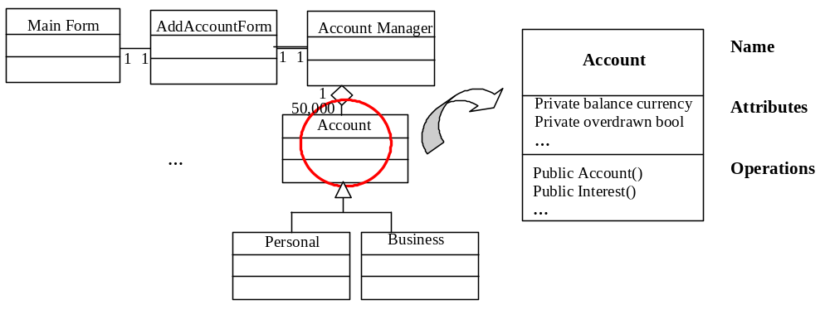 Figure 2 Example Classes and Relationships in a UML Class Diagram

The visibility of an operation or an attribute determines which classes can access it. Public visibility is the least restrictive; it means that the operation or attribute is visible to all model elements. Protected visibility means the operation or attribute is visible only to the class itself and its subclasses. Private visibility is the most restrictive; it means the operation or attribute is only visible to the class itself and to friends of the class.

Relationships
The object-oriented paradigm defines a collection of relationships among classes, which include association, generalization, composition, and aggregation. Sample classes and some of the class relationships are illustrated in Figure 2. The association represents a relationship between instances of the two classes. There is an association defined if an instance of one class must know about the other in order to perform its task. In a class diagram, an association is a line connecting two classes. It can end in open arrow (indicating one way knowledge) or can be a line (indicating both classes know about each other). The generalization association between two classes indicates one class is a superclass, or parent, of the other, a child. A generalization has a line from the subclass to the superclass; the line ends in an open triangle at the superclass. The aggregation association between two classes indicates one class belongs to a collection (i.e., a whole/part relationship). An aggregation has a line from one class to another class; the line ends in an open diamond at the class representing the collection. The composition association between two classes indicates one class is required to belong to a collection (i.e., a strong whole/part relationship). Here, the part cannot exist without the whole. A composition has a line from one class to another class; the line ends in a filled in diamond at the class representing the collection.
The multiplicity of an association is the number of allowed instances of the class. Multiplicities are single numbers or ranges of numbers. Common multiplicities are presented in Table I.
Table I Common Association Multiplicities
Multiplicities | Meaning
0..1 | zero or one instance
n..m | n to m instances (e.g., 2..4)
* | zero or more instances
1 | exactly one instance
1..* | one or more instances

Objects
An instance, or object, is a specific occurrence of a class. The state of an instance is stored as the values of its data attributes; the behavior is defined by invocations of its operations. The interaction of objects can be presented using a UML sequence diagram (Figure 3) or a UML collaboration diagram. The sequence diagram below illustrates the interactions among objects to create a new bank account. The bank service representative initiates a request to add a new account for a customer by using the main form of the application. The main form sends a request to create a new add account form, which is displayed to the bank service representative. The representative fills in the form and sends a request to submit the form. In turn, a request is sent to the account manager object to create the new account. The account manager sends a request to create a new bank account for the customer.
It is important to note that message links in a sequence diagram can be defined with different levels of detail. For example, a verb phrase is often used in the early, analysis model such as “Add account request”, whereas an operation invocation is used in the detailed design model.
The behavior of objects can also be considered in the object-oriented paradigm, typically in the detailed design. For example, depending on the state of an object, the response to an event can be different. In a banking example, an account needs to be in an Active state in order to support transaction requests such as deposit, withdraw, check balance, etc. Typically, only objects with complex, state based behavior are modeled with this level of detail; a UML state transition diagram can be used. An example of a state transition diagram in the detailed design activity in presented in Section 4.2.1.3.

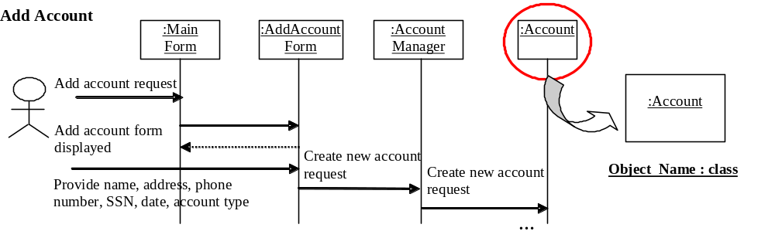
Figure 3 Example Objects in a UML Sequence Diagram

Object-oriented Analysis

Introduction
The object-oriented analysis activity focuses on developing object-oriented models of the application domain. This activity is critical, as it is the transition between the customer’s real world problem domain, captured in the requirements (e.g., a use case model), and the developer’s technical solution domain, using classes, objects, relationships, etc. In other words, the classes and objects captured in the analysis models reflect the entities found in the real world problem. The analysis models consist of static and dynamic models. The purpose of the static model is to capture the structure of the classes and their relationships. The dynamic model captures the objects and their relationships (i.e., the behavior of the objects as they execute).

Developing the Analysis Models
In order to develop the analysis models, approaches are needed to guide the identification, selection, and specification of candidate classes, objects, and their relationships, or interactions, from the requirements. The requirements are often specified using UML use case diagrams. A UML use case diagram (Figure 4) visually represents a) the people or external systems that interact with the system under development using Actors and b) the functional capabilities of the system using use cases. Actors are represented using stick figures and use cases are represented using ovals. The relationship describing which actor interacts with each use case is represented with a directed arrow. For example (Figure 4), a Bank Service Representative is an actor, who can use a variety of capabilities in the system such as adding an account, updating client information, and searching for an account. In addition, a detailed textual description for a use case can be described. Typically, the textual description includes the title, actors, overview, normal flow of events, alternate flow of events, and special (non-functional) requirements. Additional background on use case models is available [33][34][38].

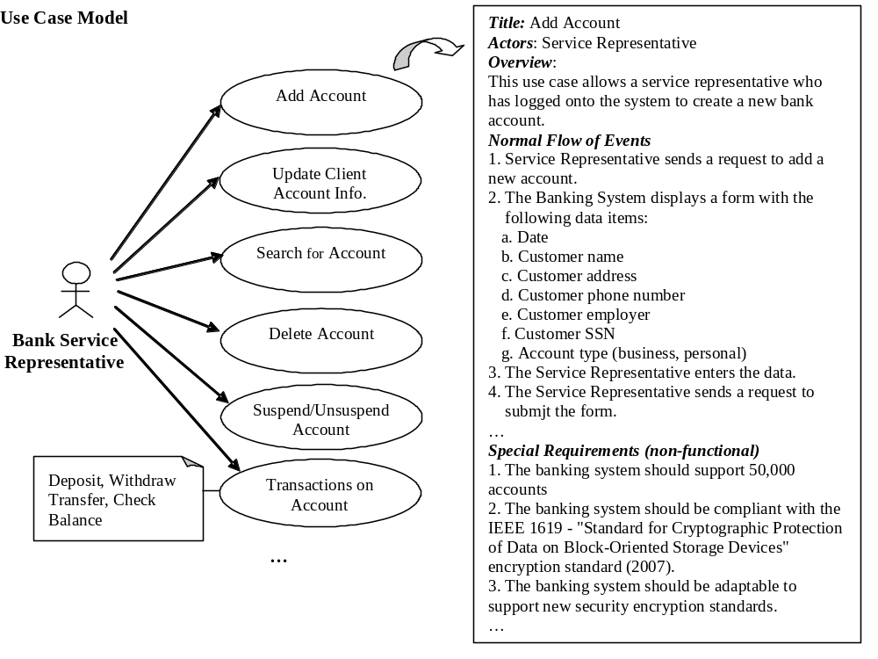Figure 4 Graphic and Textual UML Use Cases

The analysis activity generates platform independent models of the application, which do not consider the constraints of a specific solution (e.g., implementation language, development framework, etc.). In the 1980’s and 1990’s a large number of such approaches were proposed that consider the problem from different perspectives (grammatical analysis of the requirements, analysis of the data, analysis of the customers’ processes, etc.). [1][12][14][22][26][27][30][36][37][40]. These approaches assume that the classes can be (manually) identified and that the analyst can select the “useful” or “meaningful” elements to include in the models, based on their full and rich understanding of the problem domain. More recently, an interactive approach has been proposed [26], in which the client and the analyst identify, select, and specify the analysis models together. For each candidate element, questions such as: Who needs to use this? Why do they need to use it? How will they use it? How important is it? When will they use it? are discussed, so that the analyst thoroughly understands the client’s problem. As this area has matured, a framework for identifying, selecting, specifying and refining classes has been proposed [40] and an approach to automate the transformation from use-cases to object models has also been presented [27].
Three kinds of classes are traditionally identified in the analysis activity: entity, boundary, and control [21][23]. Entity classes are used to model the “things” that are long lived in the software system. For example, an Account in a banking system is an entity class. Boundary classes are generally used to model classes that support input and output to and from the software system. Actors, which can be end users or other systems, interact with the software system using the boundary classes. For example, boundary classes are used to model a graphical user interface’s widgets. Control classes are used to model classes that accomplish complex tasks. Control classes can use other control classes or entity classes to accomplish their tasks.
One of the original approaches, by Abbott, uses a grammatical analysis of the requirements written in natural language to identify candidate classes, objects, and relationships [1] (refer to Table II for a partial list of the parts of speech and their corresponding modeling element). This approach can be applied on requirements written in natural language, whether they are in paragraph form, scenario based requirements, notes on class-responsibility-collaboration (CRC) cards, or textual use cases. In this article, use cases are used to illustrate the identification of candidate classes, objects, and relationships (Figure 5)
The heuristics for identifying classes use three categories of nouns and noun phrases: common nouns; proper nouns and other forms of direct reference and mass; units of measure; and abstract nouns. A common noun (e.g., account) is a name of a class of beings or things. A common noun can be used in sentences with limiting modifiers such as a, an, every, this, that, etc. Additional examples include customer, statement, etc. A proper noun (e.g., The Bank of America) is a name of a specific being or thing. A direct reference (e.g., the account that is frozen) is a reference to a specific, previously identified being or thing. It may not be referred to by a name, as it may not have a name. Additional examples include this customer’s account, the Bank’s annual report, etc. A mass or abstract noun (e.g., system load) is a name of a quality, activity, or substance. A unit of measure (e.g., number of users) is a means of referring to a quantity of such a noun, i.e., an amount of some quality, activity, or substance.
The heuristics for identifying the operators use verbs, attributes, predicates, and descriptive expressions. A verb expresses an act or occurrence, which performs an action in a class. For example, save, load, print, etc. An attribute is a property, characteristic, association, or component of something. The operations identified for the attributes of a class consist of functionality, for example, to get or set its values. Note that this part of speech is used to identify both data attributes (for the classes) and their operations. A predicate designates a property or relation that can hold (TRUE) or not to hold (FALSE). For example, an operation may be identified to determine if an account balance is negative or not. A descriptive expression is a characterization for which there may be some particular object(s) that match. For example, an operation may be identified that iterates through a collection of objects that match search criteria.
Relationships among the classes and attributes can also be identified using the parts of speech. For example, having verbs are used to identify composition relationships (e.g., the customer information has the name, address, and telephone number) and being verbs are used to identify specialization/generalization (a business account is a bank account).
Table II Identifying Object-oriented Entities
Part of speech | Model component
Proper noun | Instance
improper noun | Class
adjectival phrase | Association, operation
doing verb | Operation
being verb | Classification
…

The interaction of objects can be represented in UML sequence diagrams or object collaboration diagrams. The level of detail captured in the interactions is also minimal. For example, a message link from one object to another object is generally labeled with descriptive text rather than an invocation of a specific operation with parameters. The normal flow of events and the alternate flow of events in a use case can be refined into object interactions on one or more sequence diagrams (Figure 6). The sequence diagrams can be readily converted into object collaboration diagrams, which tend to provide a more compact representation of the objects and their interactions.
The entity, boundary, and control classes and their associations can be represented in UML class diagrams (Figure 5). For example, if one object sends a request to another object in the sequence diagram, then an association between the two classes is included in the class diagram. In Figure 6, there is a request in the sequence diagram from the main form object to the add account form object. This relationships is captured in the class diagram as an association between the main form class and the add account form class.
The level of detail captured about the classes in the analysis model is minimal. For example, perhaps only a small number of operations (if any) are identified in each class; detailed descriptions of its argument list, return type, visibility, and pre- and post-conditions are not considered in the analysis model. These details are very likely to change as the analysis model evolves into the detailed design model, causing unnecessary re-work.

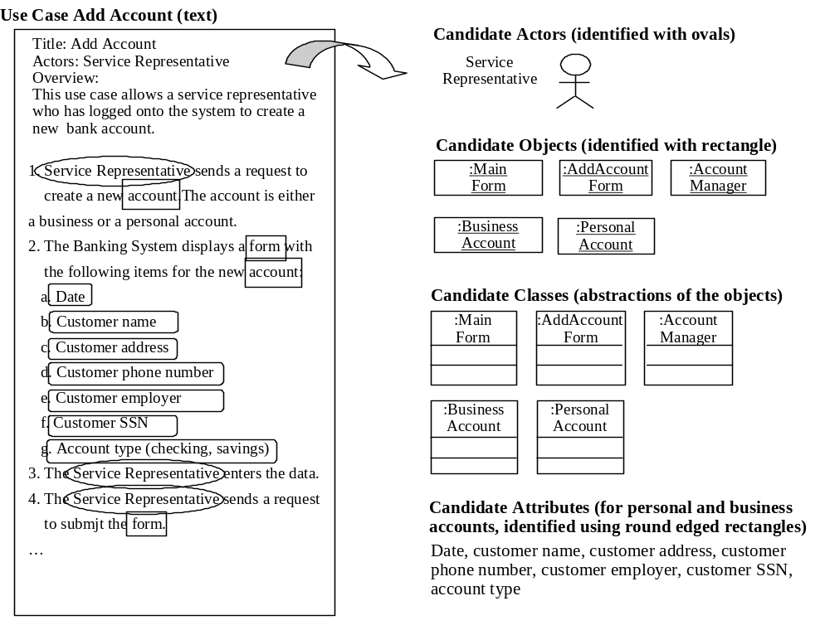
Figure 5 Identifying Candidate Objects and Attributes

Evaluating the Quality of the Analysis Models
The quality of analysis models can be evaluated using a variety of techniques, including checklists and traceability matrices. Checklists have been used for quite sometime in software engineering, particularly since Fagan’s seminal paper on design and code inspections [15]. Their advantages stem from their simplicity, ease-of-use, cost-effectiveness, and support for thorough evaluation of software artifacts. Comprehensive checklists have been composed, as presented in [4][18][24][33]. Checklists for the analysis models are available, which range from broad, general statements (e.g., the model should be consistent, complete and clear) to more specific statements (e.g., each class should be named with a noun phrase). The more general checks are suitable for experts. For individuals with less experience, the more specific checks provide straightforward, concrete checks that contribute to ensuring the consistency, completeness, and clarity of the analysis model. Examples of specific checks include:
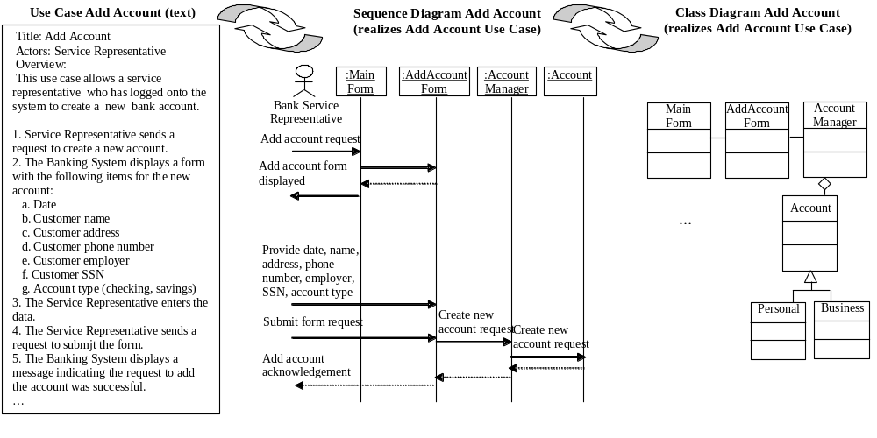Figure 6 Create Class and Sequence Diagrams

- Each class should be named with a noun phrase (control classes may be an exception)
- Each object should be named with a noun phrase (control objects may be an exception)
- The name of a class or object should clearly indicate its purpose
- Each object is created before it is used (cross check with initialization part of model)
- Each class has an object used in a sequence diagram (parent or abstract classes are exceptions)
- Each object in a sequence diagram is of a class type defined in a class diagram
- Classes/objects are clearly defined as entity, boundary, or control
- Each class is associated with one or more other classes (check for isolated classes)
- Each object that appears on a sequence diagram is used
- Control objects use other control objects and/or entity objects
- Entity objects do not use control objects
- Rationale for the model is provided
- Analysis model supports all of the capabilities defined in the use case model (as shown in traceability matrix).
Traceability matrices can be used to relate artifacts at one level of refinement to artifacts at the subsequent level of refinement. For example, use cases can be traced to the analysis models in a matrix. Each use case can be traced to one or more sequence diagrams defined in the analysis model (refer to Table III).

Table III Traceability Matrix (Use Cases:Sequence Diagrams)
Use Case Identifier  (use case model) | Sequence Diagram Identifiers  (analysis model)
Use case 1. Add new account | Analysis Sequence Diagram 1 (normal flow of events)  Analysis Sequence Diagram 2 (alternate flow of events)
Use case 2. Delete existing account | Analysis Sequence Diagram 3 (normal flow of events)  Analysis Sequence Diagram 4 (alternate flow of events)  Analysis Sequence Diagram 5 (alternate flow of events)
Use case 3. Update customer account information | Analysis Sequence Diagram 6 (normal flow of events)
Use case 4. Send account statement | Analysis Sequence Diagram 7 (normal flow of events)  Analysis Sequence diagram 8
…

The matrix helps to ensure each use case has been considered in one or more sequence diagrams (i.e., requirements have not been missed) and every sequence diagram that is defined realizes requirements defined in the use case model (i.e., additional requirements have not crept into the models).

Object-oriented Design

Introduction
In order to develop the detailed design approaches are needed to guide the refinement and restructuring of the analysis models into the detailed design models. The refinement often begins with the identification and unambiguous definition of class operations and data attributes in the static model. Fully defined operations typically have the following: name, typed parameter list, return type, visibility, pre- and post-conditions, exceptions, and a brief description. The fully defined attributes have, for example, a name, type, visibility, and constraints (e.g., a value range). The definitions of the operations and the attributes need to conform to the syntax of the implementation language. The restructuring involves the identification of inheritance and aggregation relationships among the classes, combining small classes in the analysis model into one class in the design model, dividing a class in the analysis model into one or more classes due to its size or complexity, and introducing design patterns to solve specific problems.
As the static models are refined and restructured (e.g., class diagrams), the dynamic models also need to be revised (e.g., sequence diagrams). For example, the freeform text on links in a sequence diagram (analysis model) is replaced with the specific operation invocations defined in the detailed design model. In addition, the state-based behavior of complex objects may also be defined in the detailed design.
The refinement and restructuring of the static and dynamic models occurs iteratively. The resulting models are platform specific and consider the constraints of a specific solution (e.g., implementation language, development framework, commercial off the shelf components, etc.). As with the analysis models, a number of such approaches were proposed in the 1980’s and 1990’s [12][14][22][26][27][30][36][37][40].

Developing the Detailed Design Models
The refinement of the analysis models into detailed design models can include providing additional details for the operations, attributes, and states; identifying inheritance relationships to improve the level of re-use; removing redundancy in the model (i.e., removing duplicate classes); re-structuring the model (merging or breaking up classes); and applying existing solutions to specific design problems (using design patterns). Both the static and dynamic models are iteratively refined.

Refinements Within Classes and Objects

Class Operations
The operations for each class need to be identified and fully defined in the detailed design models. Few operations are identified in an analysis model. The use cases in the requirements model cannot provide enough information to identify all operations needed in a class, as the requirements are a blackbox description of the system’s behavior. The following questions can be used to help with the comprehensive identification of operations:
- Is there a way to create an object of the class (i.e., constructor)?
- Are there operations defined to get and set each attribute defined in the class (i.e., read and update)?
- Is there a way to delete an object of the class (i.e., destructor, language specific)?
- What other operations are needed, such as one to check if two objects are equal, create a copy of the object, search for an object with specific attribute values, save/load the object, etc.
The name of the operation should be short, clearly describe its purpose, and conform to the syntax of the implementation language.
Once identified, the operations need to be substantially refined. The goal is to rigorously represent operations that can be unambiguously implemented. The refinements include defining a typed parameter list, return type, visibility, pre- and post-conditions, exceptions, and a brief description. The designer may also define the pseudo-code for the operation, depending upon the design standards or guidelines adopted for the project. For the parameter list, each parameter should have a descriptive name, type, and a description. The description should include the meaning of the parameter, whether it is passed by value or reference, whether the parameter is required or optional, valid ranges for the parameter, and side effects (i.e., does the operation change a parameter passed by reference). The export visibility of the operation needs to be defined (public, protected, private). The most restricted visibility possible which can still accomplish the objectives of the operation should be selected. Messages on sequence diagrams can be used to determine the visibility required. If a message invoking an operation is coming from a class outside the inheritance structure, then the operation requires public visibility. If the message invokes an operation from a subclass, then the operation requires protected visibility. If the message invokes an operation within a class or a friend of the class, then the operation requires private visibility. Including the pre-conditions, post-conditions, exceptions, and a short description of each operation can clarify its purpose to the implementers.
The refinement of operations is partially illustrated in Figure 7, using the Account class from the analysis model.
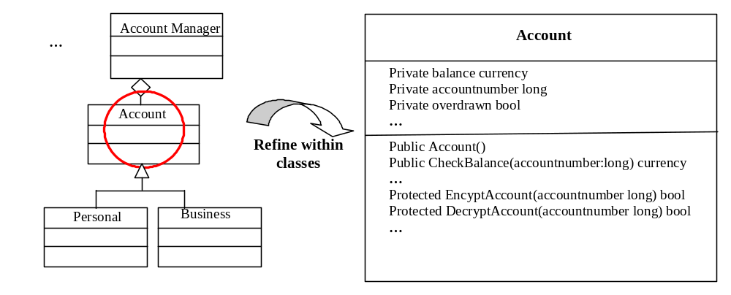 Figure 7 Example Class Refinement in a UML Class Diagram

Class Attributes
The attributes for each class need to be identified and fully defined in the detailed design models. A preliminary set of attributes may be identified in an analysis model, often using descriptive names. In the detailed design the name, type, initial or default value, visibility, and for persistent classes, whether the attribute is persistent or transient need to be defined for each attribute. The name of the attribute should be short, clearly describe its purpose, and conform to the syntax of the implementation language. The export visibility of the attribute needs to be defined (public, protected, private). The most restricted visibility possible should be selected.
The refinement of data attributes is partially illustrated in Figure 7, using the Account class from the analysis model.

Object States
For some objects, their behavior can depend upon what state it’s in; there can be a large number of complex interactions to consider. In such cases, a state machine can be defined to clearly describe the object’s behavior. If an object presents the same behavior regardless of its current state, then a state machine is not necessary. The definition of the state machine can begin identifying the initial state and the final states. For example, in a banking system, an Account’s initial state can be when it is created for a client; a final state can be when it is closed. Additional states can be identified by looking at the boundary values of the data attributes. For example, an account that has not been used for a period of time, e.g., six months, may be changed from an active to a suspended state. The state names should be brief and descriptive, to improve their communication value. The definition of transitions between states can begin by determining the event that a) moves the object from one state to a different state or b) triggers a recursive transition (from/to the same state). Some of the operations in the class will correspond to transitions and/or states in the state machine. For example, in a banking system Account, there can be operations to open, process transactions (check balance, deposit, withdraw, transfer), suspend, reactivate, and close an account.
The refinement of an object’s behavior is partially illustrated in Figure 8, using the Account class from the analysis model.
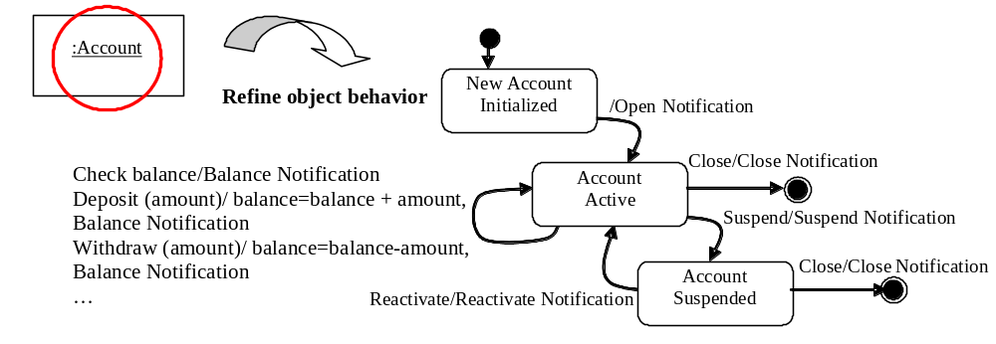 Figure 8 Example Object Refinement in UML State Transition Diagram

Refinements Among Classes
The detailed design models, in particular the static model, can be restructured in the detailed design to improve quality attributes of the design such as re-usability, performance, maintainability, etc. Re-usability can be improved by identifying and defining improvements to the inheritance structure in the design. Performance can be improved by the addition of associations or reorganizing the class structure. Maintainability of the design can be improved by applying design patterns to solve well-known design problems. The designer needs to balance the trade-offs that result from these restructuring activities. For example, improving the maintainability of the design by applying design patterns may decrease the performance of the design.

Define Generalizations
The analysis model may contain a small number of generalization associations, if any. In the detailed design, a generalization hierarchy needs to be defined to exploit the common behavior and structure in classes. A common parent, or super-class, can be defined from which children, or sub-classes, inherit both behavior and structure. The common structure and behavior are defined in one place and re-used in the design and the subsequent implementation.
The identification of possible inheritance relationships involves examining the names, attributes and operations in the analysis model for similarity. For example, the similarity may be the use of a common noun, but with different adjectives in the names of classes. For example, class names such as Personal Account, Business Account, Mortgage Account, Savings Account, and Checking Account may exist in the model; these are candidates for an inheritance relationship with Account as the super-class. Synonyms or acronyms may be present to describe data attributes or operations; if a common collection of attributes and operations can be identified, then this is also a candidate for an inheritance relationship.

Application of Design Patterns
Design patterns [17] provide well-proven solutions to specific design problems. They provide a common vocabulary that improves the designer’s ability to communicate and understand the system; consider alternative (existing) solutions to design problems; and provide a means of effectively documenting the software design. As design patterns often involve collections of classes or objects, their application may require the addition and/or deletion of classes in addition to restructuring the design.
The original collection of design patterns [17] consists of 23 patterns that were grouped into three categories: creational, structural, and behavioral Table IV). Creational patterns provide solutions for class instantiation problems, either class-creation patterns or object-creational patterns. Structural patterns provide solutions for class and object composition problems. Behavioral patterns provide solutions for communication problems between objects.

Table IV Summary of Design Patterns (Gamma, 1995)
Category | Patterns
Creational Patterns | Abstract Factory groups object factories that have a common theme  Builder constructs complex objects by separating construction and representation  Factory Method creates objects without specifying the exact class to create  Prototype creates objects by cloning an existing object  Singleton restricts the object creation for a class to only one instance
Structural Patterns | Adapter allows classes with incompatible interfaces to work together by wrapping its own interface around that of an already existing class  Bridge decouples an abstraction from its implementation so that the two can vary independently  Composite composes one-or-more similar objects so that they can be manipulated as one object  Decorator dynamically adds/overrides behaviour in an existing method of an object  Facade provides a simplified interface to a large body of code  Flyweight reduces the cost of creating and manipulating a large number of similar objects  Proxy provides a placeholder for another object to control access, reduce cost, and reduce complexity
Behavioral Patterns | Chain of responsibility delegates commands to a chain of processing objects  Command creates objects which encapsulate actions and parameters  Interpreter implements a specialized language  Iterator accesses the elements of an object sequentially without exposing its underlying  Mediator allows loose coupling between classes by being the only class that has detailed knowledge of their methods representation  Memento provides the ability to restore an object to its previous state (undo)  Observer is a publish/subscribe pattern which allows a number of observer objects to see an event  State allows an object to alter its behavior when its internal state changes  Strategy allows one of a family of algorithms to be selected on-the-fly at runtime  Template method defines the skeleton of an algorithm as an abstract class, allowing its subclasses to provide concrete behavior  Visitor separates an algorithm from an object structure by moving the hierarchy of methods into one object

Additional sources have become available to assist designers in the selection and application of design patterns using a variety of object-oriented programming languages, including Java and C++ [3][19].
As an example, an adapter pattern is presented and applied.in the banking system example (Figure 6). The adapter, also known as the wrapper pattern, is a structural pattern that provides a way for a client to use an object (an adaptee) when the interface between the client and the adaptee don’t match. In the class diagram shown for an adapter pattern (Figure 9), the client wants to make a specific request of a method in an adaptee object. Ordinarily, this could be accomplished by creating an instance of Adaptee and invoking the method directly. However, if the interfaces don’t match, then the client needs to be modified. The adapter pattern modularizes the interface into a new class (adaptor), localizing the changes to redefine data types on the client's behalf. A key advantage of this solution is that it does not lead to modifications in the client. The adapter can be used to react to changes in class interfaces as the system evolves, or can be proactively used to build systems that anticipate structural changes.
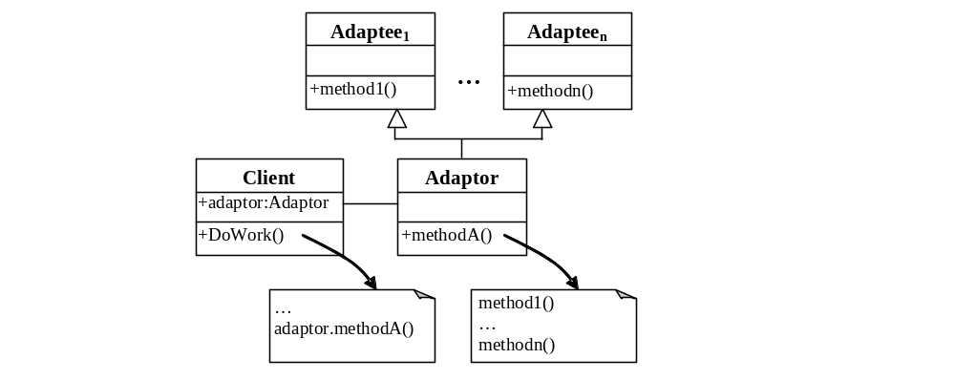
Figure 9 Adaptor Design Pattern

In the banking system example, the requirement to be able to adapt to different security encryption/decryption standards in the future leads to the selection and application of the adapter pattern (Figure 10). The Account class is the client in the pattern; new classes for the adaptor and adaptee classes are added to the design. When additional security standards and components become available, the design and implementation can be readily extended.

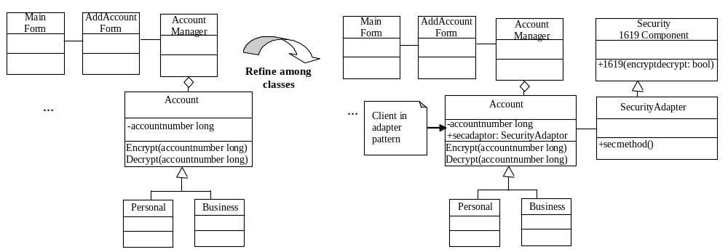
Figure 10 Example Class Diagram Refinement by Applying Adapter Design Pattern

Evaluating the Quality of the Detailed Design Models
The quality of the detailed design models can be evaluated using a variety of techniques, including checklists and traceability matrices (like the analysis models). In addition, metrics for the detailed design models are available.
Checklists for the detailed design models are also available, which range from broad, general statements (e.g., the model should be consistent, complete and clear) to more specific statements (e.g., each class should be named with a noun phrase). The more general checks are suitable for experts. For individuals with less experience, the more specific checks provide straightforward, concrete checks that contribute to ensuring the consistency, completeness, and clarity of the analysis model. Examples of specific checks are listed below. A subset of these checks is also applicable to the analysis model.
- Each class should be named with a noun phrase (control classes may be an exception)
- Each object should be named with a noun phrase (control objects may be an exception)
- The name of a class or object should clearly indicate its purpose
- Each object is created before it is used (cross check with initialization part of model)
- Each class has an object used in a sequence diagram (parent or abstract classes are exceptions)
- Each object in a sequence diagram is of a class type defined in a class diagram
- Classes/objects are clearly defined as entity, boundary, or control
- Each class is associated with one or more other classes (check for isolated classes)
- Each object that appears on a sequence diagram is used
- Control objects use other control objects and/or entity objects
- Entity objects do not use control objects
- Messages on sequence diagrams labeled with an operation invocation, including parameters
- Contracts are specified for classes
    - Each signature in each class has pre- and post-conditions defined. if there are no pre-conditions, for example, then write "None"
    - Class invariants are defined
- Each operation invoked in a sequence diagram is present in the class
- Each operation in each class is invoked in a sequence diagram.
- Each class has a constructor, destructor (language dependent)
- Rationale for the model is provided

As discussed in Section 3.3, traceability matrices can be used to relate artifacts at one level of refinement to artifacts at the subsequent level of refinement. For example, use cases can be traced to one or more sequence diagrams defined in the detailed design. Alternatively, sequence diagrams in the analysis model (if available) can be related to the sequence diagrams in the detailed design. The matrix helps to ensure requirements have not been missed and additional requirements have not crept into the design.
A number of object-oriented design metric suites have been proposed to help ensure the quality of a detailed design [2][11][25][29][41]. Comparative surveys are available [6][13]. The metrics are intended to provide an objective way to measure specific quality attributes of a design, including complexity, coupling, and cohesion. If a measurement is outside a desirable range, then the design can be modified earlier in the development lifecycle, reducing the longer term maintenance costs.
Here, an overview of complexity, coupling, and cohesion metrics is presented. Examples, primarily from the metrics suite proposed by Chidamer and Kemerer [11], are provided; this is a well-known and widely used suite [16].
Complexity metrics quantify attributes of the design that indicate the difficulty in implementation, testing, and maintenance. They include metrics related to the size of classes (i.e., number of methods), inheritance structure of the design, and the size of the response to a message (i.e., number of methods that could be invoked). For example, the weighted methods per class metric focuses on the complexity and number of methods within a class. Higher values indicate higher, long term maintenance costs for the class. With respect to inheritance, the depth of the inheritance tree measures how many layers of inheritance make up a given class hierarchy. A higher number indicates strong re-use in the design, but modifications to the classes lower in the tree are likely to take more time, as the class inherits methods and attributes from multiple levels. Also related to inheritance is the number of children metric, which is the number of immediate specializations for a given class. A higher number indicates strong re-use in the design and is an indication that the design must realize additional responsibilities (i.e., the system is more complex). The response for a class is the number of different methods that can potentially be executed in response to a message received by an object. Higher numbers indicate that the design is more complex and may be more difficult to maintain.
Coupling metrics quantify the interactions between modules. Lower coupling measures are desirable, indicating the design is more flexible and easier to modify in the future. As an example, a straightforward metric has been proposed by different authors, which is the number of different classes with which a class can interact. This metric has a number of names: coupling between object classes; the number of collaborating classes; and the number of subsystem-subsystem relationships. The metric counts the number of other classes from which methods or attributes are used.
Cohesion metrics quantify interactions within a module. Highly cohesive modules are considered more understandable, modifiable, and maintainable. As an example, the lack of cohesion in methods metric is based on measuring the number of attributes two methods use in common [11]. The lack of cohesion is calculated as the difference between the number of methods who do not share attributes and those that do. Lower values for this metric are desirable, as they indicate high cohesiveness.

Summary
This article begins with an overview of the object-oriented paradigm that includes descriptions of key principles and basic concepts in addition to an established object-oriented modeling notation (Unified Modeling Language). Following this, presentations on the object-oriented analysis and object-oriented design activities are provided. The presentations include an introduction, description of the activity’s workflow, and approaches used to evaluate the quality of the models produced. A banking system example is used to illustrate the analysis and design activities; UML is used as the notation to represent the models.

References

- R. Abbott, “Program design by informal English description”, Communications of the ACM, vol. 26, no. 11, pp. 882-894, 1983.
- F. Abreu and R. Carapuca, “Candidate Metrics for Object-oriented Software within a Taxonomy Framework”, Journal of Systems and Software, vol. 26, issue 1, pp. 87-96, July 1994.
- A. Alexandrescu, Modern C++ Design: Generic Programming and Design Patterns Applied, Addison-Wesley Professional, 2001.
- APM Document Template website, R.S. Pressmann & Associates, Inc., “Adaptable Process Model – Software Engineering Checklists,” available at: http://www.rspa.com/checklists/index.html
- J. Arlow and I. Neustadt, UML 2 and the Unified Process: Practical Object-Oriented Analysis and Design, Second Edition, Addison-Wesley, 2005.
- A. Binkley and S. Schach, “A comparison of sixteen quality metrics for object-oriented design”, Information Processing Letters, vol. 58, issue 6, pp. 271-275, June 1996.
- G. Booch, Software Engineering with Ada, Benjamin/Cummings, 1983.
- G. Booch, Object-Oriented Design with Applications, Benjamin Cummings Publishing Company, 1991.
- B. Bruegge and A. Dutoit, Object-Oriented Software Engineering: Using UML, Patterns and Java, Prentice Hall, 2003.
- L.F. Capretz, “A brief history of the object-oriented approach”, SIGSOFT Software Engineering Notes, vol. 28, no. 2, pp. 1-10, 2003.
- S.R. Chidamber and C.F. Kemerer, "A Metrics Suite for Object-Oriented Design," IEEE Transactions on Software Engineering, vol. 20, no. 6, pp. 476 – 493, June 1994.
- P. Coad and E. Yourdon, Object-Oriented Analysis, Prentice Hall, 1991.
- M. El-Wakil and A. Fahmy, “Object-Oriented Design Quality Models A Survey and Comparison”, in proceedings of the 2nd International Conference on Informatics and Systems, March 2004.
- D.W. Embley, B.D. Kurtz, and S.N. Woodfield, Object-oriented System Analysis: A Model-Driven Approach, Prentice-Hall, 1992.
- Fagan, M., “Design and Code Inspections to Reduce Errors in Program Development,” IBM Systems Journal, vol. 15, no 3, pp. 182-211, 1976.
- N. Fenton and S.L. Pfleeger, Software metrics: A Rigorous and Practical Approach, second edition, PWS Publishing, 1998.
- E. Gamma, R. Helm, R. Johnson, and J. Vlissides, Design Patterns: Elements of Reusable Object-Oriented Software, Addison Wesley, 1995.
- T. Gilb and D. Graham, Software Inspection, edited by Susannah Finzi, Reading, MA: Addison-Wesley, 1993
- M. Grand, Patterns in Java, Volume 1, A Catalog of Reusable Design Patterns Illustrated with UML, John Wiley & Sons, 1998.
- Hamilton, J.A. and Pooch, U.W., “A Survey of Object-oriented Methodologies”, in Proceedings of the conference on TRI-Ada '95: Ada's role in global markets: solutions for a changing complex world, 1995, pp. 226-234.
- I. Jacobson, G. Booch, and J. Rumbaugh, The Unified Software Development Process, Addison-Wesley, 1999.
- I. Jacobson, M. Christerson, P. Jonsson, and G. Overgaard, Object-oriented Software Engineering: A Use Case Driven Approach, Addison Wesley, 1992.
- P. Kroll and P. Krutchten, The Rational Unified Process Made Easy, Addison-Wesley, USA, 2003.
- S. Lauesen, Software Requirements: Styles and Techniques, Pearson Education Limited, 2002.
- W. Li and S. Henry, "Object-Oriented Metrics that Predict Maintainability," J. Systems Software, vol. 23, no. 2, 1993, pp. 111-122.
- Y. Liang, D. West, and F.A. Stowell, “An approach to object identification, selection and specification in object-oriented analysis”, Information Systems Journal, vol.8, no.2, pp. 163-80, April 1998.
- D. Liu, K. Subramaniam, B.H. Far, and A. Eberlein, “Automating Transition from Use-cases to class model”, in the Proceedings of the IEEE Canadian Conference on Electrical and Computer Engineering, 2003, pp. 831-834.
- K. Liu, S. Zhou and H. Yang, “Quality Metrics of Object Oriented Design for Software Development and Re-development”, in the proceedings of the First Asia-Pacific Conference on Quality Software, 2000, pp. 127 – 135.
- M. Lorenz and J. Kidd, Object-Oriented Software Metrics, Prentice Hall, 1994.
- J. Martin and and J.J. Odell, Object-oriented Analysis and Design, Prentice Hall, 1992.
- Object Management Group, OMG Unified Modeling Language Specification. Version 2.0, 2004, available at http://www.omg.org.
- M. Page-Jones, Practical guide to structured systems design, Englewood Cliffs, NJ, Prentice-Hall, 1988.
- S.L. Pfleeger, L. Hatton, and C.C. Howell, Solid Software, Prentice-Hall, 2001.
- R. Pressman, Software Engineering A Practitioner’s Approach, McGraw-Hill Professional, 2005.
- J. Rumbaugh, J. Blaha, M. Premeralni, F. Eddy, and W. Loresenson, Object-oriented modelling and design, Prentice Hall, 1991.
- S. Shlaer and S.J. Mellor, Object Lifecycle: Modelling the World in States, Prentice Hall, 1992.
- S. Shlaer and S.J. Mellor, Object-Oriented System Analysis: Modelling the World in Data, Prentice Hall, 1988.
- I. Sommerville, Software Engineering, eighth edition, Addison-Wesley, 2007.
- S.S. Yau and J. Tsai, “A survey of software design techniques”, IEEE Transaction on Software Engineering, vol. SE-12, no. 6, pp. 713-721, June 1986.
- Wahono, R.S. and Far, B.H., “A framework for object identification and refinement process in object-oriented analysis and design”, in Proceedings of the First IEEE International Conference on Cognitive Informatics, 2002, pp. 351-360.
- L. Wei and H. Salley, “Maintenance Metrics for the Object Oriented Paradigm”, in Proceedings of the First International Software Metrics Symposium, 1993, pp. 52-60.
- R. Wieringa, “A survey of structured and object-oriented software specification methods and techniques”, ACM Computing Surveys, vol. 30, no. 4, pp. 459-527, December 1998.

